Hedging BTC with Perpetual Bitcoin Inverse swaps

#### 1 Introduction

##### 1.1 Objective and Description

The **objective** of our project is to use perpetual Bitcoin inverse swaps to hedge the Bitcoin and have an implication of the effectiveness of our hedging strategy in different types of markets and different time windows. When crypto traders bet on BTC rising in value and want to hedge in case there is a short-term decline. The need for hedging in crypto markets cannot be overstated. The inherent volatility of cryptocurrencies, exemplified by the roller-coaster rides in the value of assets such as Bitcoin and Ethereum, presents both opportunities and perils. While the potential for substantial gains is alluring, the risks are equally daunting. It is in this environment that hedging strategies become a paramount consideration for market participants.

The **expectation** we have is to display the hedging results with real history data in different scenarios and get better results when using the swaps hedging strategy. The **measurement metrics** would be but not limited as follows:

* Cumulative Hedging PNL: including total PNL, asset PNL, and hedging contract PNL
* Maximum Drawdown: showing the risk we could reduce with the hedging strategy
* Relative volatility (scaled): giving the direct display of volatility with time changes

##### 1.2 Description of BTC Perpetual Swaps

In the real industry, there are several types of strategies to reduce underlying risk in cryptocurrency assets. According to the website and lecture notes, we take a deep search and list the methods below[1]. We will have a brief explanation and talk about why we would like to choose the perpetual inverse swaps.

* Swap with Stablecoin: This strategy involves swapping cryptocurrencies with stablecoins, providing a means to reduce exposure to market volatility.
* Short Selling in Cryptocurrency Markets: Here, traders aim to profit from falling cryptocurrency prices by borrowing and selling digital tokens. Bitsgap, a prominent trading platform, facilitates this approach.
* Diversification: Diversifying a cryptocurrency portfolio across assets that exhibit a negative correlation can potentially help spread risk.
* Insurance: While insurance options exist for cryptocurrency-related risks, such as private key loss, smart contract vulnerabilities, or wallet provider failures, it may require the purchase of several individual insurance policies, making it a less comprehensive approach.
* Futures and Options: Futures and options markets provide sophisticated tools for risk management. There are Bitcoin futures contracts offered by Cboe and CME, as well as Bitcoin options.
* Perpetuals (Futures with No Expiration Date): Perpetual contracts, commonly referred to as "crypto perps," are a particular type of derivative known as "futures." Unlike traditional futures, perpetuals do not have an expiry date. We provide an in-depth definition and explanation of perpetual contracts, covering key aspects like funding rates, margin requirements, and settlement mechanisms.

BTC perpetual swaps are a type of cryptocurrency derivative, and they work a bit differently than traditional futures. The primary features of BTC perpetual swaps include: (i) **Funding Rate**: This is a fee paid between traders to ensure the perpetual contract's price aligns with the Bitcoin spot price. It helps to prevent price discrepancies and maintain stability. (ii) **Margin**: Traders are required to deposit a certain amount of cryptocurrency, known as initial margin, to open a BTC perpetual swap position. The initial margin acts as collateral to cover potential losses. (iii) **Settlement**: Unlike traditional futures, BTC perpetual swaps don't have an expiration date. They continue indefinitely, making them a flexible trading instrument. Settlement occurs when traders close their positions.

Managing a BTC perpetual swap position involves calculating potential profits and losses. The PNL (Profit and Loss) calculation formula includes:



For short positions, the formula is slightly different:



The PNL formulas estimate how much traders can gain or lose based on the difference between their entry and exit prices and their position size.

Crypto perpetual swaps play a vital role in the cryptocurrency ecosystem: Flexibility: Perpetual swaps offer traders the ability to hold positions for as long as they want, without worrying about contract expirations. Liquidity: These contracts are often highly liquid, with active trading on various platforms. Risk Management: Traders use BTC perpetual swaps to hedge their existing cryptocurrency portfolios or speculate on future price movements. Accessibility: With a lower initial margin requirement (typically 5% on platforms like dYdX), these swaps are accessible to a wide range of traders. BTC perpetual swaps are innovative financial instruments that provide traders with flexibility, liquidity, and risk management capabilities. Understanding their features, calculations, and significance is crucial for anyone looking to navigate the dynamic world of cryptocurrency trading. These contracts offer a unique way to participate in the exciting and volatile Bitcoin market while managing risk effectively. And this is the reason why we would like to choose the strategy and have research on its performance.

#### 2 Hedging Strategy

(finally, we choose BTC/USD inverse perpetual swaps, with the position long 1 BTC and short h contracts of inverse perpetual swaps, where h is the hedging ratio)

##### 2.1 Basic Assumption and Notification

* Assume that using BTC as the measurement of PNL and we need to transform the value to USD with the BTC price on the last day.
* In solidity, assume that no float type so we multiply all the variables with 10^18 which are related to values.
* This is the strategy of buy-and-hold: At the initial time, we long n BTC and short m contracts and hold. Contracts might be settled at some time and that trade ends.
* Assume no transaction cost.
* Assume we have a bank account with limited capital and the initial margin account. If there is a margin call for the swap, the bank account will automatically transfer the amount required to the margin account.
* Assume each perpetual Bitcoin inverse future is worth 1 BTC.
* Assume the risk-free rate is 0, which means the money in the bank account won’t grow.

##### 2.2 Hedging Method

At time 0, we buy n BTC (we also can assume BTC was bought earlier, it’s the same.) and short m perpetual bitcoin inverse future at the same time.

Here, the hedge ratio decides the relationship between n and m: m = n * hedge ratio.

Since we assume each contract just worth 1BTC, hedge ratio = 100% seems to be a perfect hedge. (Further discussion will be in Section 4.)

In our simulation, we won’t settle the contract manually or based on other profit or loss-related conditions. Therefore, it is a pure buy-and-hold strategy. However, the only case in the contract is settled is that we go bankrupt, which means our capital could not cover the margin required when the price of BTC rises too much. So, this strategy is suitable for the situation in BTC is predicted to fall.

#### 3. Code implementation

In this section, we are going to introduce how we realize the strategy using solidity. To simulate the real scenario, we would use 2 contracts. One solidity contract, PerpatualSwap.sol is the implementation of a perpetual swap contract; the other contract is our Strategy.sol, which will contain a new swap contract and interact with it.

First, let’s see the structure of PerpatualSwap.sol

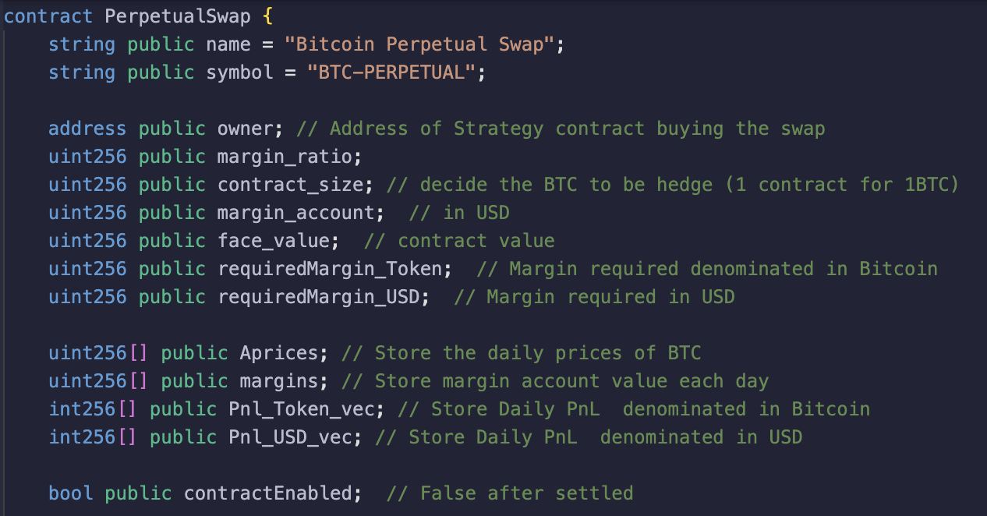

constructor(): receive the initial token price, initial margin account, margin ratio and contract size.

2 modifiers:

whenContractEnabled(): some execution action can be called only when contact is active.

onlyOwner(): only the owner can call some functions.

1 event:

MarginAdded(): emit when there is a margin call.

10 functions:

settle(): expire swap contract

addMargin(), getMargin(), checkMargin(), withdrawMargin() are actions on margin account.

get_last_Price(), get_last_Pnl(), Margin_history(), Pnl_history() return history information.

update() is the main function of the swap contract. It receives a new Bitcoin price, and updates all the information, including the latest and history price, PnL, and margin required, and checks if triggers the margin call.

Next, let’s see the structure of Strategy.sol

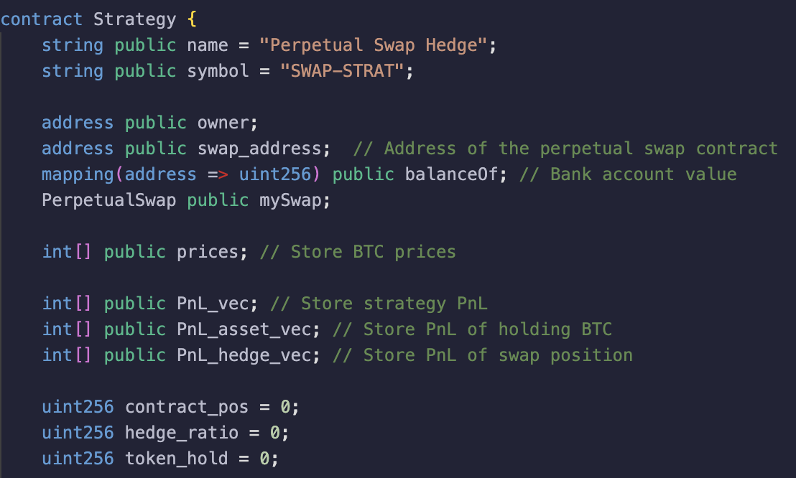

constructor(): receive the number of tokens held and hedge ratio, which could decide our contract size.

1 modifier:

onlyOwner(): only the owner can call some functions.

11 functions:

settle(): expire swap contract

get_swap_address() :return address of swap contract.

deposit(), withdraw(), checkBalanceOf():are actions on margin account of swap.

get_price(): input a price vector of BTC for strategy simulation.

simulate() is the main function of the strategy contract. It iterates on the price vector and calculates the PnL for the strategy and updates information.

Pnl_history(), Pnl_asset_history(), Pnl_hedge_history(): allows us to view total PnL, token PnL, and swap PnL of simulation.

Culmulative_Pnl() returns the cumulative PnL of the strategy after simulation.

* create a swap contract (PerpetualSwap.soi): important attributes(margin ratio, contract size, face value, Pnl of token or USD, etc) and important functions (checkMargin, update, etc)
* create a Hedging class (Strategy.sol): important attributes(Pnl of total or asset or hedge, hedge_ratio, token_hold)
* Introduction to the panel (把solidity里deploy出的漂亮面板截下图，说明下？)

#### 4 Simulation

After displaying solidity programming, we use the real history data in the crypto market to implement the simulation. In this part, we will introduce how we fetch the data and show the numerical results together with the measurement metrics we have mentioned above.

##### 4.1 Data

The dataset is Bitcoin's daily adjusted close price from 2022/1/1 to 2023/10/28 using Yahoo Finance API. After fetching the data, we make basic settings and numerical assumptions: (i) Divide the dataset into two periods, 2022/1/1 to 2022/12/31 (Bear Market), 2023/1/1 to 2023/10/28 (Bull Market); (ii) Compare the performance in two scenarios: Hedge ratio = 1 (Long 2 BTC and Short 2 Swaps) and Hedge ratio = 0.5 (Long 2 BTC and Short 1 Swap); (iii) Other settings: margin account 8000 USD, margin ratio 0.5, etc.

##### 4.2 Execution Screenshots & Results

(i) Deploy the strategy contract with token_hold=2 and hedge_ratio=1 (similarly it is 0.5 in the second case).

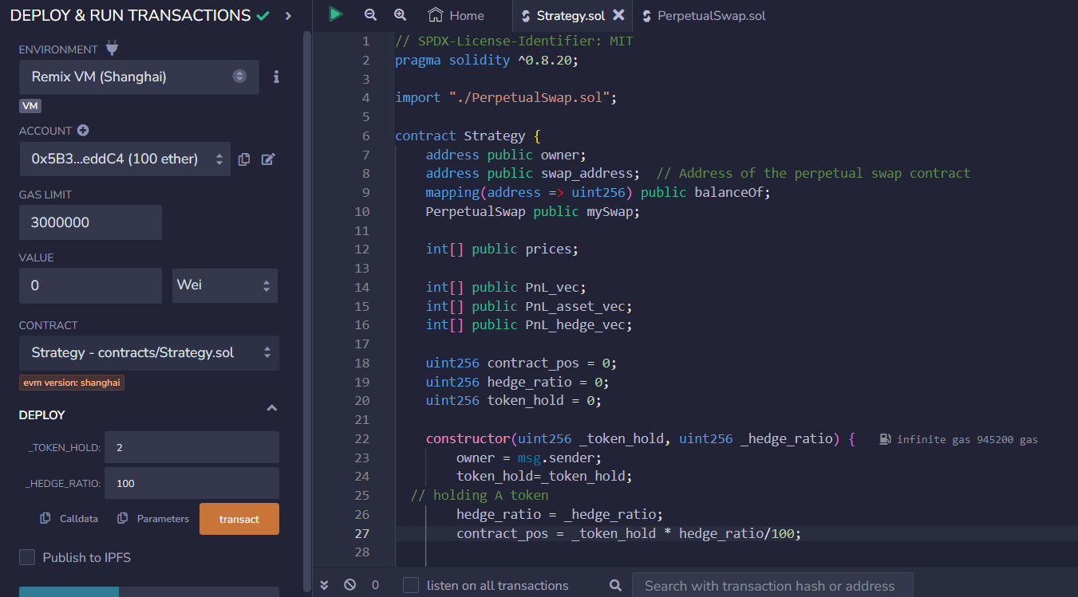

(ii) Deploy the swap contract with numeric default settings using the contract address.

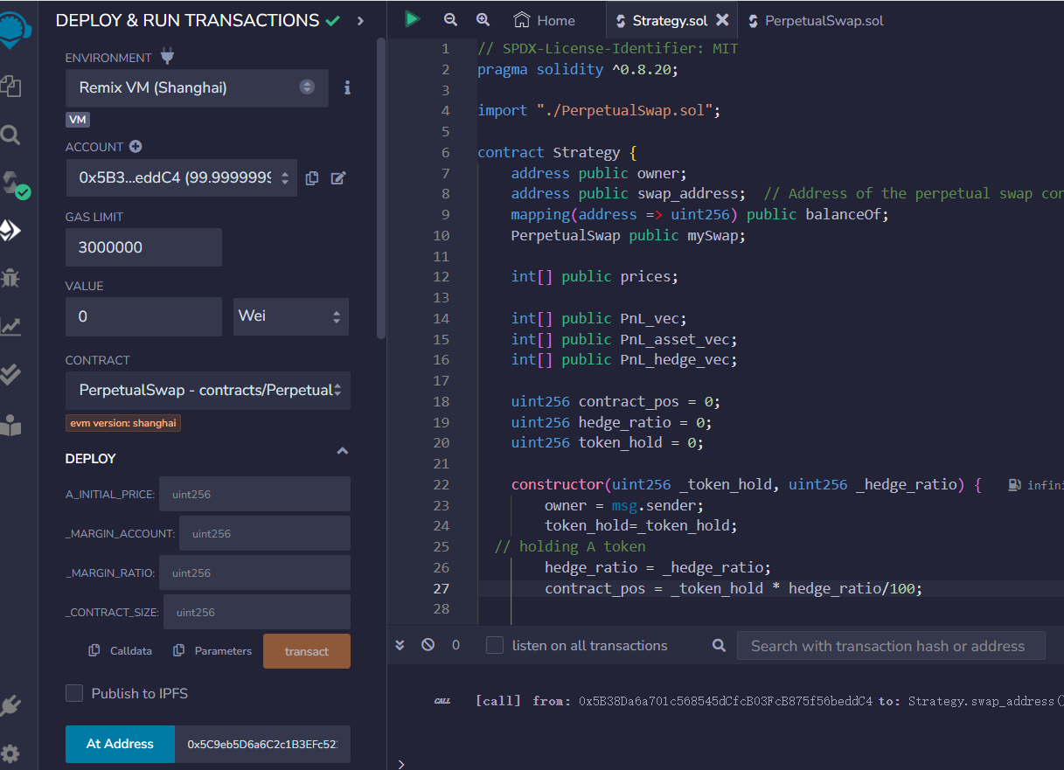

(iii) Get the price list from Yahoo Finance and transform it into the type of ‘list’, then input the list in the get_price function.

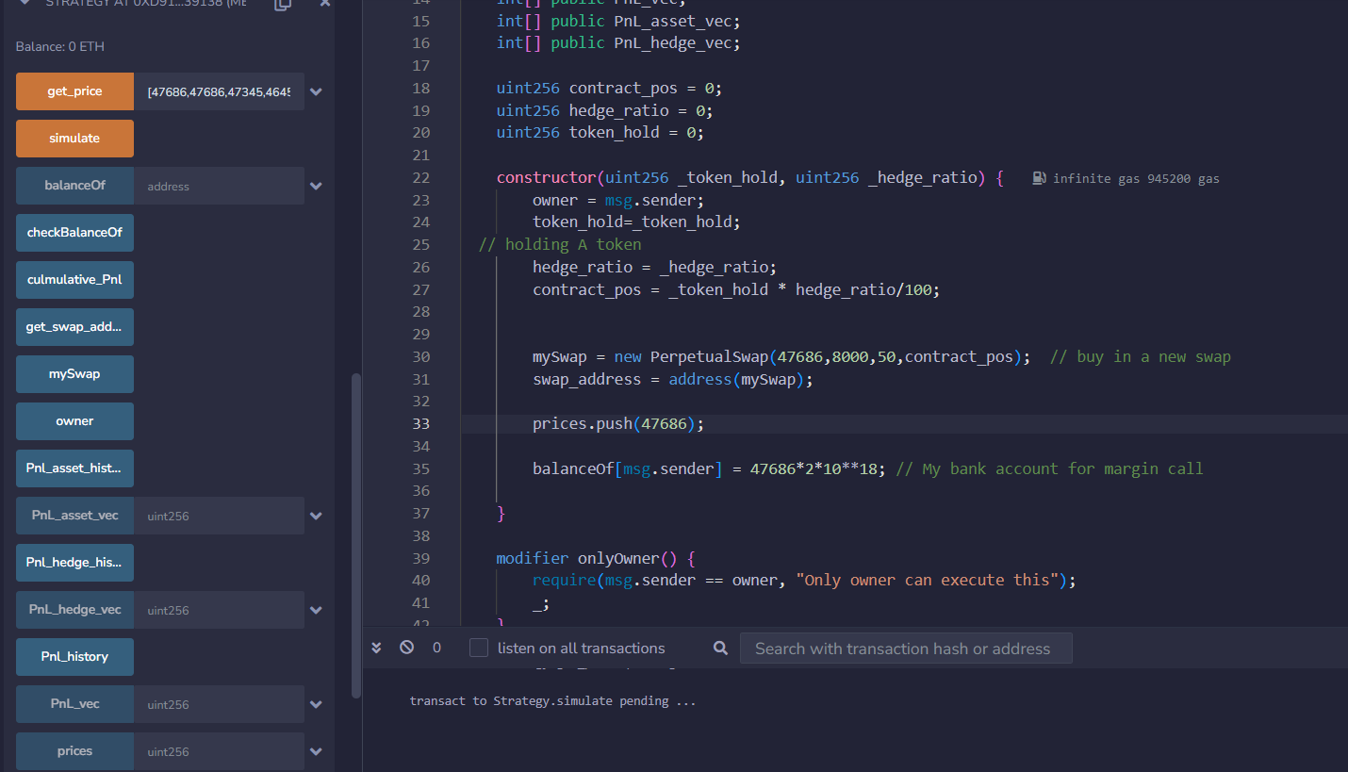

(iv) Run the simulate function and get Pnl_history. In the below picture, we could get all the listed attributes in the panel, including balance, cumulative PNL, the swap address, owner, PNL of assets/ hedging, margin account, etc.

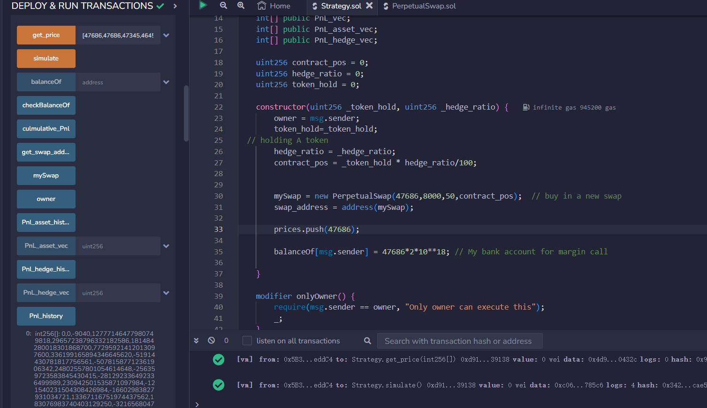

(v) Deploy the contract in MetaMask Wallet and Verification

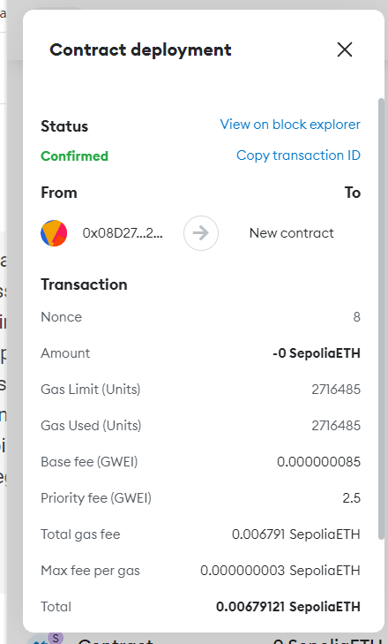

##### 4.3 PnL Result

(1) Daily PnL

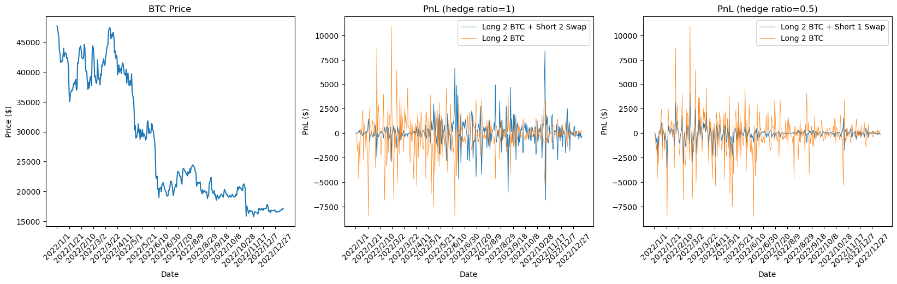

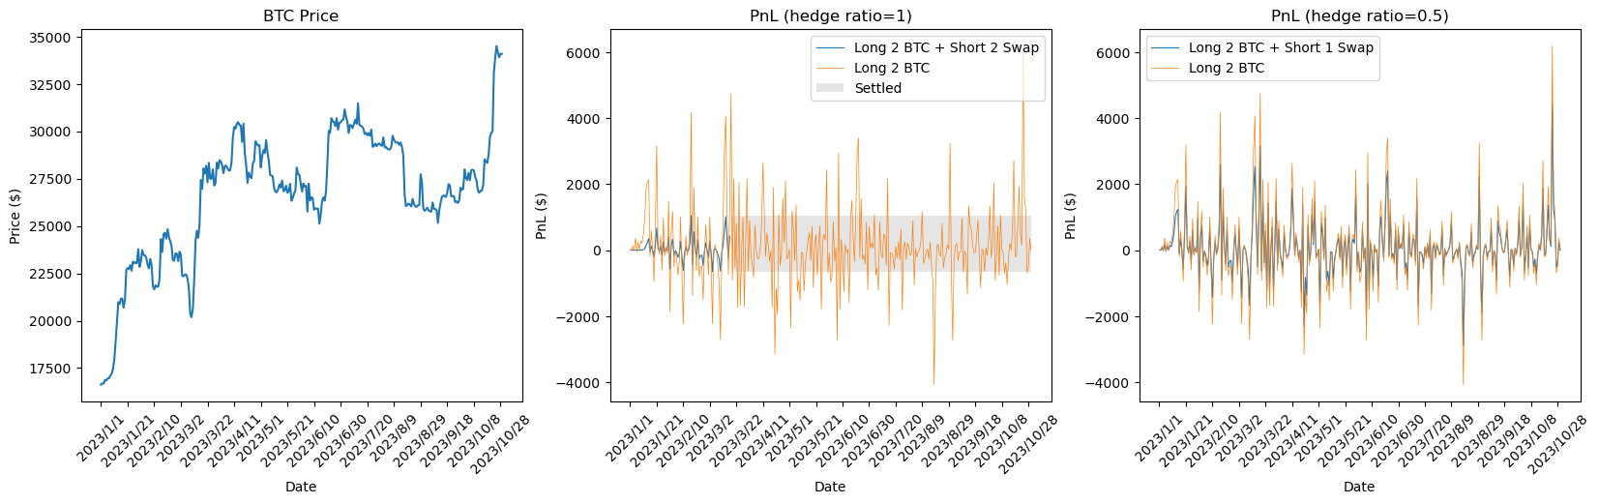

Since this strategy is used when we forecast there would be a fall in BTC price. So in the bull market, short position in swaps causes great loss and there’s not enough money to cover the margin requirement, and thus the swap settles.

(2) Cumulative PNL

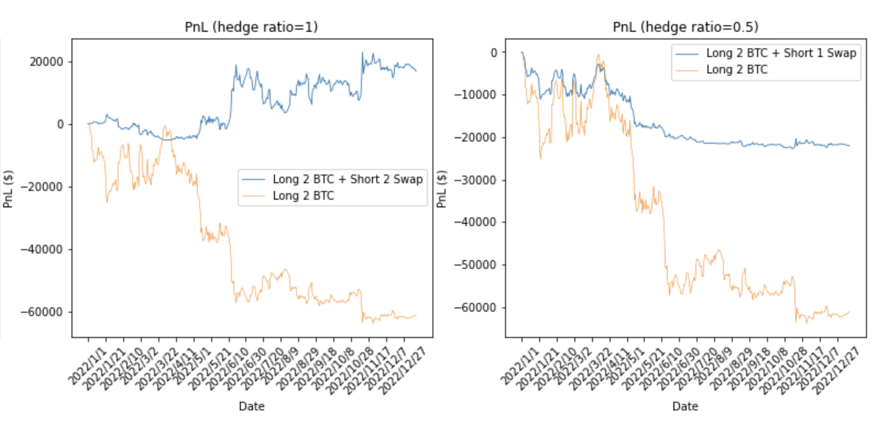

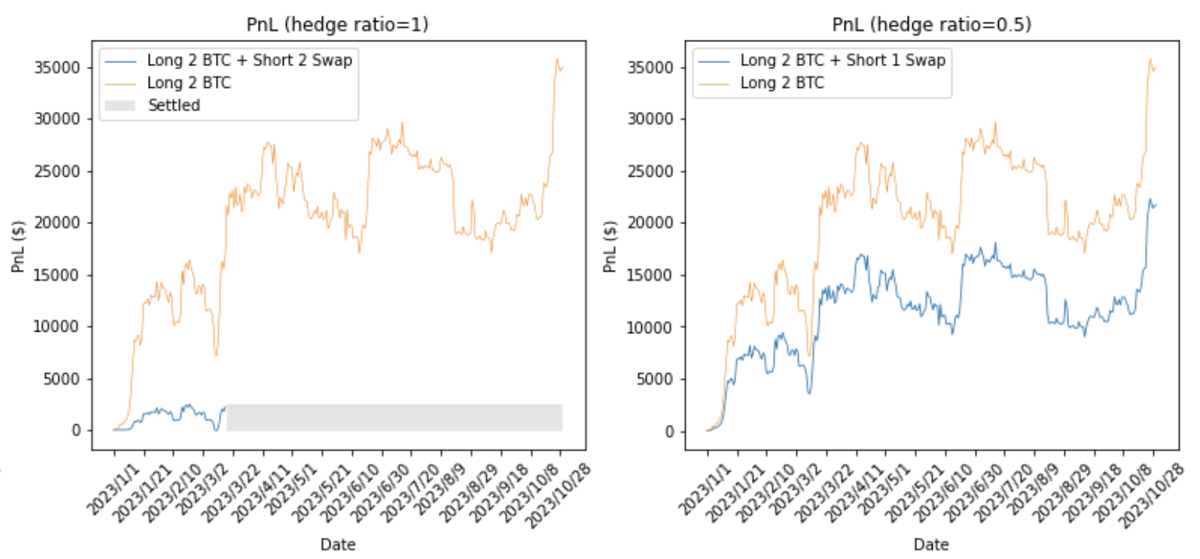

In the bear market, the cumulative PnL shows that the strategy performs really well. When the hedge ratio = 100%, there would be a relatively stable and increasing total PnL. hedge ratio = 50% can also offset much downside risk, but would also reduce positive Pnl in the bull market.

(3) Risk

(i) Maximum DrawDown

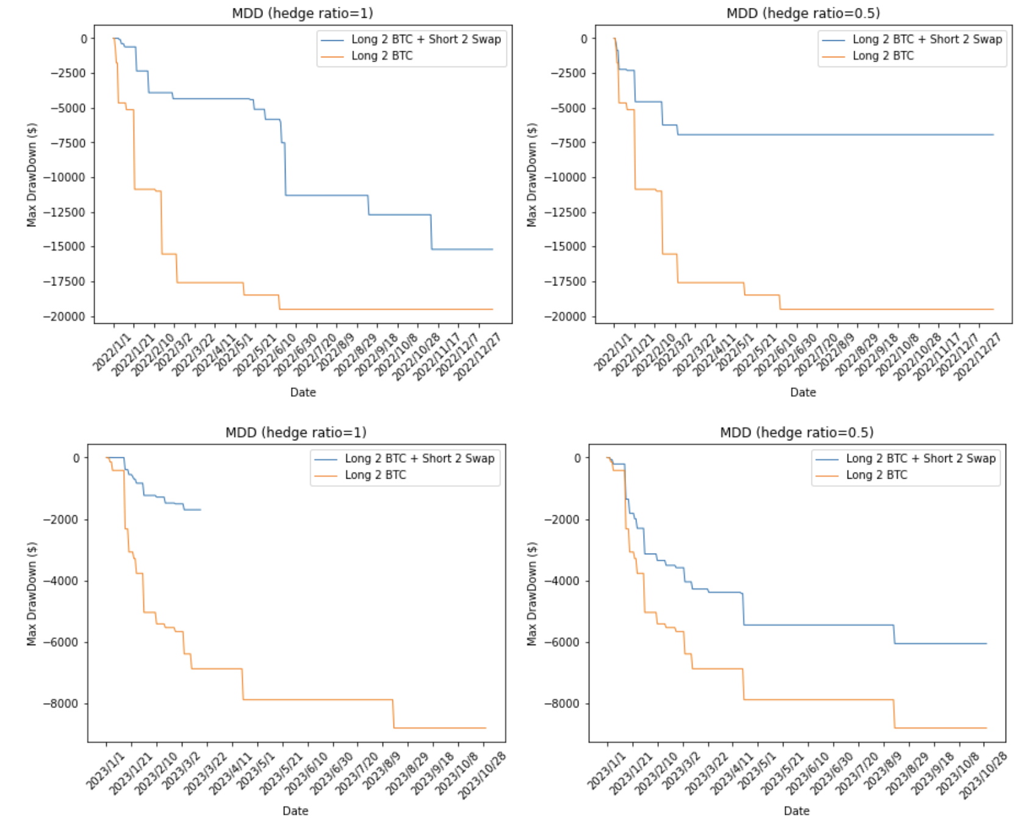

(ii)Annualized Volatility

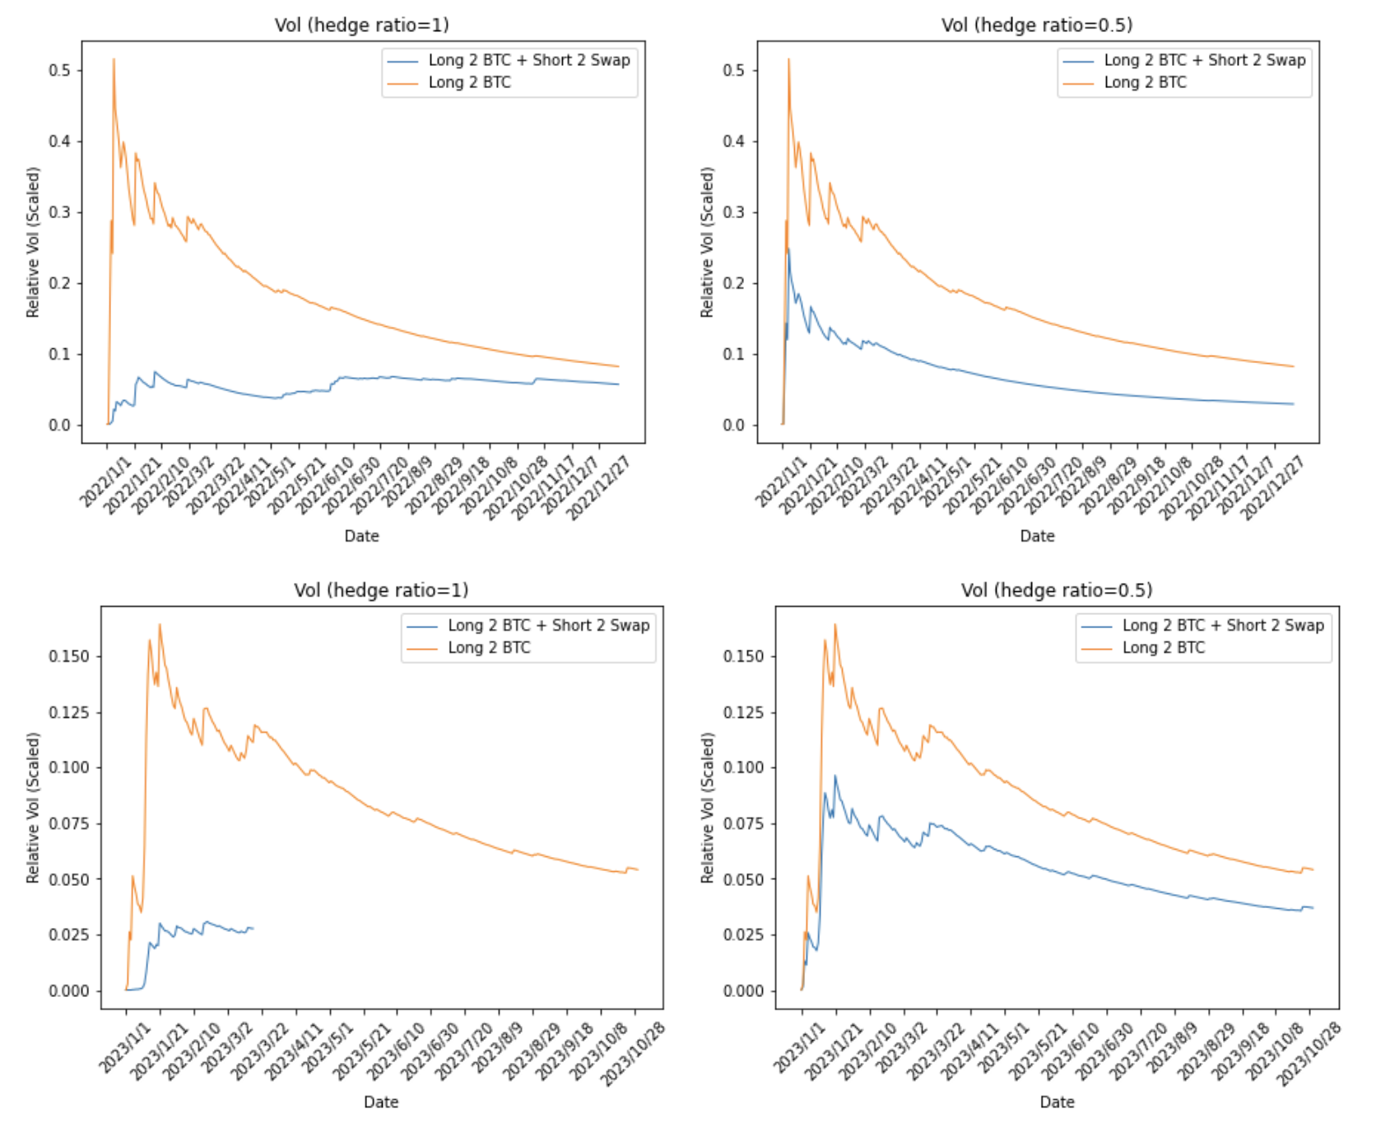

Since most of the goal of hedging is to reduce risk and stabilize our position. Let’s look at maximum drawdown and annualized volatility to see the effect of our strategy. From the above figure, we can see that the swap strategy has a lower maximum drawdown and annualized volatility.

(4) BTC PnL vs Swap PnL

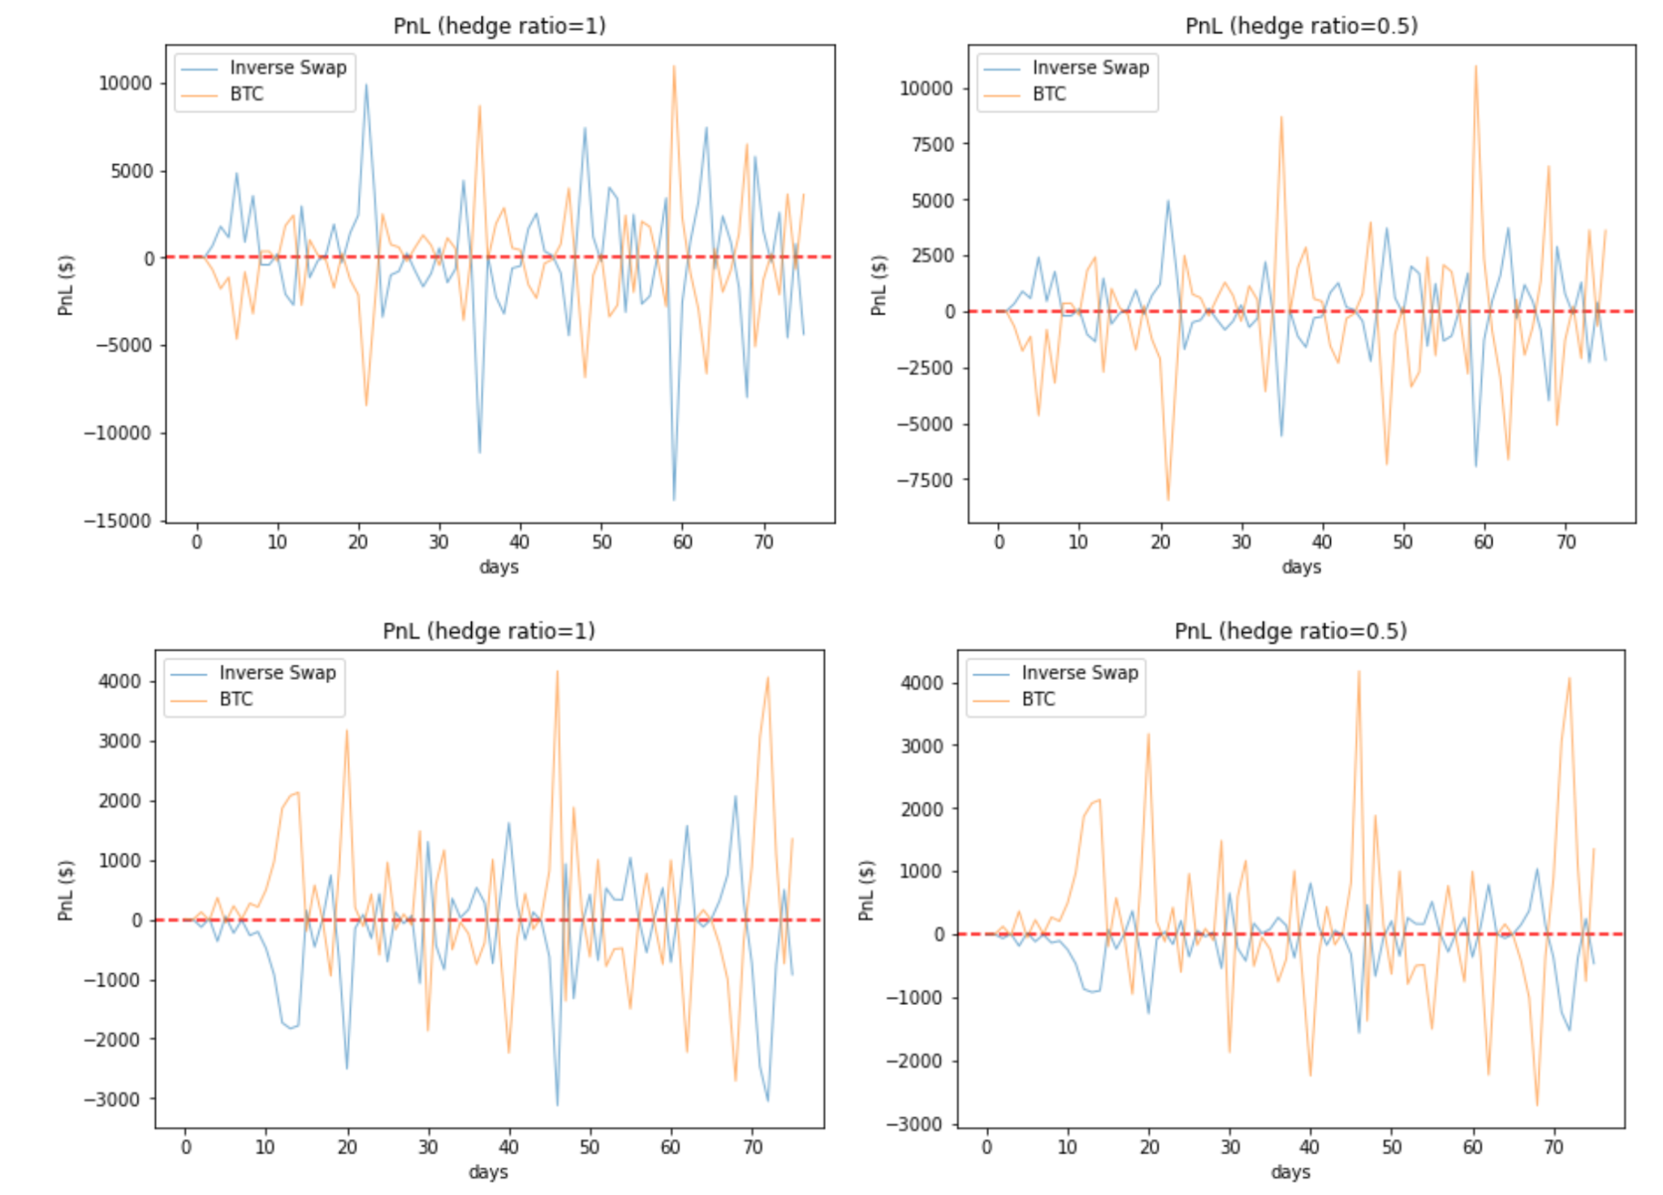

From the figure above, we can see that BTC PnL and Swap PnL seem to be symmetric, and that’s why it is a hedging strategy. However, we should notice that they are not entirely symmetric even if the hedge ratio = 100%( which means short the swap of the same value BTC holds.)

Let's assume a dx change in BTC price. The new value of swap is (face value /(last price+ dx)) BTC. The last value of the swap is (face value /(last price)) BTC. So the Pnl of short in swap nominated in BTC is face value *(1/(last price+ dx) - 1/last price), and Pnl nominated in USD is face value *(1/(last price+ dx) - 1/last price)*(last price+ dx) = face value / last price * dx

So, if the last price is higher than the face value, the absolute PnL of the swap is greater than that of BTC. So in bear markets when the hedge ratio = 1, you can see each day, the peak of the blue line(Swap) is larger in absolute value than the orange line(BTC) since face value > last price. And in bull markets, it’s the opposite.

#### 5. Conclusion and Improvement

##### 5.1 Improvements

* Our initial expectation is to hedge between two tokens, but using US dollars as collateral is more easy to understand and implement.
* We also thinking of using ECR20 created on our own and transferring tokens in a different account(which is 2 different addresses), but due to time limitations, we simplify the process, making the token values just member variables.
* We also think of different strategies, like dynamically changing the hedging ratio or setting a profit goal to settle the swap. But we want to exhibit the simple swap hedge strategy more intuitively, so we just consider the bankruptcy situation.
* We are now getting a price for simulation through input price vector, later get_price() function can be rewritten using API for more convenient price extraction. But all this above and other improvements could be realized based on our code framework.

##### 5.2 Conclusion

This strategy does well in the BTC bear market. The PnL of the strategy is stable even if the BTC markets have a dramatic fall. From our simulation results, we find hedge ratio also matters. A higher hedge ratio generates more profit during the bear market, but the cost will be higher too, considering the margin, and more risky if the forecast of market direction is wrong.

#### Reference

[1] Building Your Defense with Cryptocurrency Hedging Strategies. [https://bitsgap.com/](https://bitsgap.com/blog/cryptocurrency-hedging-strategies)

[blog/cryptocurrency-hedging-strategies](https://bitsgap.com/blog/cryptocurrency-hedging-strategies)

[2] What are Perpetual Contracts? <https://dydx.exchange/crypto-learning/perpetuals-crypto>